**The Nokesville Library**

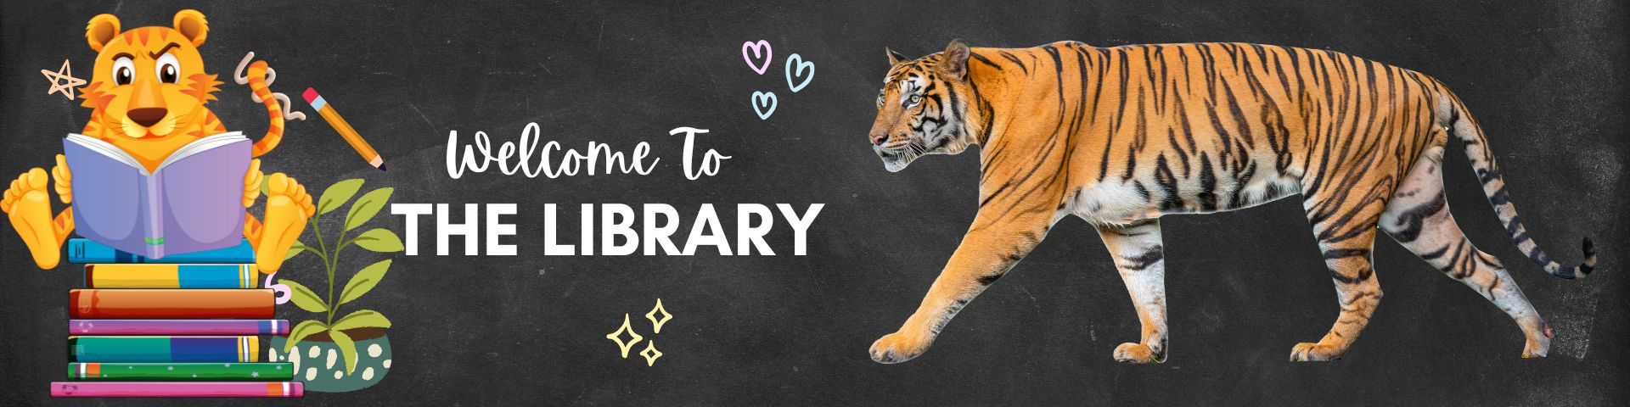

**Meet the Librarians**

**Librarian Names: Kevin Holsopple – Elementary Librarian**

**Tanya Parrott – Middle School Librarian**

**Barbara McIntosh – Library Assistant**

**Elementary Checkout Schedules**

**Library Rules:**

**Checkout**:

Kindergarten and 1st graders may check out one book at a time for one week. They may select books from the colored bins in the everyone section only.

2nd, 3rd, 4th, and 5th graders may check out two books at a time for one week. They may select books from anywhere library, but they may NOT check out a book marked with a YA sticker. YA stands for Young Adult and are for our 6th, 7th, and 8th grade students only.

6th, 7th, and 8th grade students may check out two books at a time for two weeks. They may select books from anywhere library including YA books.

**Overdue**: Books must be turned in or renewed one week after they were checked out, two if they are in middle school. If books are overdue, students may not check out new books.

**Lost or Damaged Books**: If a book is lost or damaged, we ask that you please help us in replacing it. Payments can be made in person by cash or check. We cannot take cards in person, but the county online payment system [RYCOR](https://pwcs.instructure.com/courses/351950/files/98052393?wrap=1) ([RYCOR En ESPANOL](https://pwcs.instructure.com/courses/351950/files/98052432?wrap=1)) can be used. If you cannot help in replacing the book for any reason be it financial or otherwise, we will work with you. Our number one priority is always getting books in the hands of children.

**Virginia Reader's Choice:**These are books that we may read the first chapter of throughout the year together for upper elementary. K and 1 will be reading the picture books during story time. This is a program done by the Virginia State Literacy Association. We will vote on our school's favorite title at the end of the year and submit it. Links to online reviews from School Library Journal and Kirkus are provided for each title below.

From the VRC website: Purpose - To encourage young readers to become better acquainted with contemporary books with outstanding literary appeal, to broaden students’ awareness of literature as a life-long pleasure, to encourage reading aloud in classrooms as a means of introducing reading for pleasure, and to honor favorite books and their authors.

[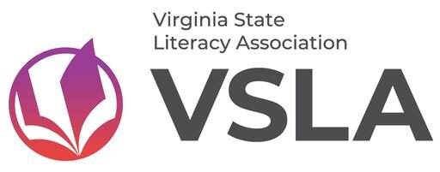](https://vslatoday.org/VRC)

**Lower Elementary: Grades K-2**

[**The River That Wolves Moved: A True Tale for Yellowstone by Mary Kay Carson**](https://www.kirkusreviews.com/book-reviews/mary-kay-carson/the-river-that-wolves-moved/)

[**The Green Piano: How Little Me Found Music by Roberta Flack and Tonya Bolden**](https://www.slj.com/review/the-green-piano-how-little-me-found-music)

[**Farmhouse by Sophie Blackall**](https://www.slj.com/review/farmhouse)

[**Eggasaurus by Jennifer Wagh**](https://www.slj.com/review/eggasaurus)

[**Poo-Dunit? A Forest Floor Mystery by Katelyn Aronson**](https://www.kirkusreviews.com/book-reviews/katelyn-aronson/poo-dunit/)

[**Hattie Harmony Worry Detective by Elizabeth Olsen**](https://www.slj.com/review/hattie-harmony-worry-detective)

[**Blue Bison Needs a Haircut by Scott Rothman**](https://www.slj.com/review/blue-bison-needs-a-haircut)

[**That's Not My Name by Anoosha Syed**](https://www.kirkusreviews.com/book-reviews/anoosha-syed/thats-not-my-name/)

[**Somewhere in the Bayou by Jarett & Jerome Pumphrey**](https://www.slj.com/review/somewhere-in-the-bayou)

[**I Cannot Draw a Horse by Charise Mericle Harper**](https://www.slj.com/review/i-cannot-draw-a-horse)

**Upper Elementary: Grades 3-5**

[**Odder by Katherine Applegate**](https://www.slj.com/review/odder)

[**A Rover's Story by Jasmine Warga**](https://www.slj.com/review/a-rovers-story)

[**Squished by Megan Wagner Lloyd and Michelle Mee Nutter**](https://www.slj.com/review/squished)

[**A Duet for Home by Karina Glaser**](https://www.slj.com/review/a-duet-for-home-audio)

[**Dog Squad by Chris Grabenstein**](https://www.slj.com/review/dog-squad)

[**The Lion of Lark-Hayes Manor by Aubrey Hartman**](https://www.kirkusreviews.com/book-reviews/aubrey-hartman/the-lion-of-lark-hayes-manor/)

[**Seeking Freedom: The Untold Story of Fortress Monroe and the Ending of Slavery in America by Selene Castrovilla**](https://www.kirkusreviews.com/book-reviews/selene-castrovilla/seeking-freedom/)

[**The Legend of Gravity: A Tall Basketball Tale by Charly Palmer**](https://www.slj.com/review/the-legend-of-gravity-a-tall-basketball-tale)

[**Swim Team by Johnnie Christmas**](https://www.slj.com/review/swim-team)

[**Anybody Here Seen Frenchie? by Leslie Connor**](https://www.slj.com/review/anybody-here-seen-frenchie)

**Virginia Reads: Like Virginia Reader's Choice, Virginia Reads is a reading program consisting of 10 books. This program is sponsored by VAASL, the Virginia Association of School Librarians. You can click the VAASL button below to find more information. We will be voting on these books at the end of the year as well. Below the VAASL button there are links to School Library Journal and Kirkus reviews for each title.**

[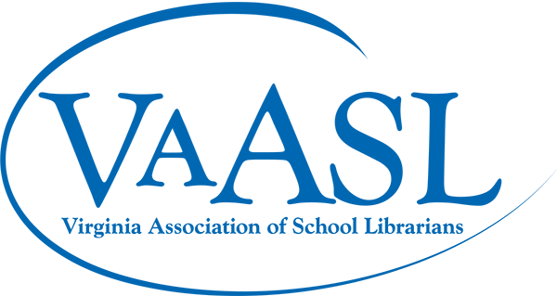](https://www.vaasl.org/vareadsbooklist)

**Picture Books**

[**Sari-Sari Summers by Lynnor Bontigao**](https://www.kirkusreviews.com/book-reviews/lynnor-bontigao/sari-sari-summers/)

[**Little Red Riding Hood and the Dragon by Ying Chang Compestine**](https://www.kirkusreviews.com/book-reviews/ying-chang-compestine/little-red-riding-hood-and-the-dragon/)

[**Wepa by J de laVega**](https://www.slj.com/review/wepa)

[**Cooler Than Lemonade: A Story about Great Ideas and How They Happen by Harshita Jerath**](https://www.kirkusreviews.com/book-reviews/harshita-jerath/cooler-than-lemonade/)

[**Not a Monster by Claudia Guadalupe Martinez**](https://www.kirkusreviews.com/book-reviews/claudia-guadalupe-martinez/not-a-monster/)

[**The Boy Who Tried to Shrink His Name by Sandhya Parappukkaran**](https://www.slj.com/review/the-boy-who-tried-to-shrink-his-name)

[**The Tree of Hope: The Miraculous Rescue of Puerto Rico's Beloved Banyan by Anna Orenstein-Cardona**](https://www.slj.com/review/the-tree-of-hope-the-miraculous-rescue-of-puerto-ricos-beloved-banyan)

[**A Letter for Bob by Kim Rogers**](https://www.slj.com/review/a-letter-for-bob)

[**Ramen for Everyone by Patricia Tanumihardja**](https://www.kirkusreviews.com/book-reviews/patricia-tanumihardja/ramen-for-everyone/)

[**Nell Plants a Tree by Anne Wynter**](https://www.slj.com/review/nell-plants-a-tree)

**Chapter Books**

[**Greenwild: The World Behind the Door**](https://www.slj.com/review/greenwild-the-world-behind-the-door)

[**Link + Hud: Heroes by a Hair by Jarrett Pumphrey and Jerome Pumphrey**](https://www.slj.com/review/heroes-by-a-hair)

[**Curlfriends: New in Town by Sharee Miller**](https://www.slj.com/review/curlfriends-new-in-town)

[**Morning sun in Wuhan by Ying Chang Compestine**](https://www.kirkusreviews.com/book-reviews/ying-chang-compestine/morning-sun-in-wuhan/)

[**Miles Lewis: King of the Ice**](https://www.slj.com/review/king-of-the-ice)

[**A Seed in the Sun by Aida Salazar**](https://www.slj.com/review/a-seed-in-the-sun)

[**Sparkle by Lakita Wilson**](https://www.slj.com/review/sparkle)

[**The Many Masks of Andy Zhou by Jack Cheng**](https://www.kirkusreviews.com/book-reviews/jack-cheng/the-many-masks-of-andy-zhou/)

[**The Misfits: A Royal Conundrum by Lisa Yee**](https://www.slj.com/review/a-royal-conundrum)

[**The Takeout by Tracy Badua**](https://www.kirkusreviews.com/book-reviews/tracy-badua/the-takeout/)